Sentosa

A
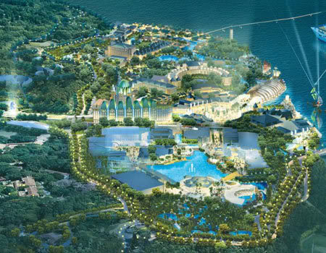
fter the Japanese surrender in 1945 and the return of Singapore to British rule, the island became the base of the locally enlisted First Singapore Regiment of the Royal Artillery (1st SRRA) in 1947. Other locally enlisted men from Singapore were sent to the island for basic military training before being sent to other units of the British Army in Singapore.
Ten years later, the 1st SRRA was disbanded and its guns dismantled. The coast artillery was replaced with Gurkha infantry units, first the 2/7th Duke of Edinburgh's own Gurkha Rifles and later the 2/10th Princess Mary's own Gurkha Rifles. Fort Siloso and Fort Serapong became a Catholic retreat and a Protestant church house respectively. Fort Connaught was left in ruins.
In the early 1960s, during the Indonesian Confrontation, the 2/10th unit defended the island against Indonesian saboteurs. With the end of the Confrontation in 1966 and the withdrawal of the Gurkha units from the island, the British handed over Sentosa to the Singapore Armed Forces of the newly independent Government of Singapore in 1967.
In 1967, Pulau Blakang Mati became the base for the Singapore Naval Volunteer Force, which relocated there from its old base at Telok Ayer Basin. The School of Maritime Training was also set up there, as was the first Naval Medical Centre.
In the 1970s, the government decided to develop the island into a holiday resort for local visitors and tourists

. Source : http://en.wikipedia.org/wiki/Sentosa

.

